**React Handson – 9**

**CODE:**

**App.js: -**

import IndianPlayers from './IndianPlayers';

import ListOfPlayers from './ListOfPlayers';

function App() {

  const flag=true;

  return (

    <div>

      {flag? <ListOfPlayers />:<IndianPlayers/>}

    </div>

  );

}

export default App;

**ListOfPlayers.js: -**

export default function ListOfPlayers() {

    const players = [

        { name: "Jack", score: 50 },

        { name: "Michael", score: 70 },

        { name: "John", score: 40 },

        { name: "Ann", score: 61 },

        { name: "Elisabeth", score: 95 },

        { name: "Sachin", score: 95 },

        { name: "Dhoni", score: 100 },

        { name: "Virat", score: 84 },

        { name: "Jadeja", score: 64 },

        { name: "Raina", score: 75 },

        { name: "Rohit", score: 80 },

    ];

    const playersBelow70 = players.filter(player => player.score < 70);

    return (

        <div>

            <h1>List of Players</h1>

            <ul>

                {players.map((item) => (

                    <li>Mr. {item.name} <span>{item.score}</span></li>

                ))}

            </ul>

            <hr />

            <h1>List of Players having Scores Less than 70</h1>

            <ul>

                {playersBelow70.map((item) => (

                    <li>Mr. {item.name} <span>{item.score}</span></li>

                ))}

            </ul>

        </div>

    );

}

**IndianPlayers.js: -**

export default function IndianPlayers() {

    const IndianPlayers = ['Sachin', 'Dhoni', 'Virat', 'Rohit', 'Yuvraj', 'Raina'];

    const [First, , Third, , Fifth] = IndianPlayers;

    const [, Second, , Fourth, , Sixth] = IndianPlayers;

    const T20players = ['First Player', 'Second Player', 'Third Player'];

    const RanjiTrophyPlayers = ['Fourth Player', 'Fifth Player', 'Sixth Player'];

    const allPlayers = [...T20players, ...RanjiTrophyPlayers];

    return (

        <div>

            <h1>Odd Players</h1>

            <ul>

                <li>First : {First}</li>

                <li>Third : {Third}</li>

                <li>Fifth : {Fifth}</li>

            </ul>

            <hr />

            <h1>Even Players</h1>

            <ul>

                <li>Second : {Second}</li>

                <li>Fourth : {Fourth}</li>

                <li>Sixth : {Sixth}</li>

            </ul>

            <hr />

            <h1>List of Indian Players Merged: </h1>

            <ul>

                {allPlayers.map((player, idx) =>

                    <li key={idx}>Mr. {player}</li>

                )}

            </ul>

        </div>

    );

}

**OUTPUT:**

**When flag==true**

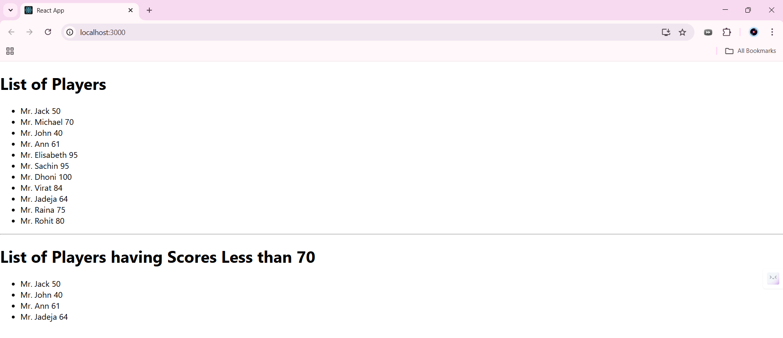

**When flag==false**

